**EXIT THE PLUGIN**

### A MINI PROJECT REPORT

#### Submitted by

#### Group/Team No: G8/Team 7

**JATIN AHUJA**  **2210991706**

**JATIN BANSAL 2210991707**

**JATIN DHINGRA 2210991708**

**JATIN GARG**  **2210991709**

## BACHELEOR OF ENGINEERING

***in***

COMPUTER SCIENCE & ENGINEERING

Subject=FEE-I(22CS004)



**CHITKARA UNIVERSITY**

**CHANDIGARH-PATIALA NATIONAL HIGHWAY**

**RAJPURA (PATIALA) PUNJAB-140401 (INDIA)**

##### **April/2023**

CONTENT

|  |  |  |
| --- | --- | --- |
| 1. | Abstract | Page3 |
| 2. | Introduction | Page 3 |
| 3. | Problem Statement | Page 3 |
| 4. | Technical Details | Page3 |
| 5. | Key features | Page4 |
| 6. | Advantages | Page4 |
| 7. | Code With Output | Page5 |
| 8. | Conclusion with future scope | Page7 |
|  |  |  |

**ABSTRACT**

"Exit the plugin" is a type of software plugin that is designed to help website owners reduce their website's bounce rate and increase conversions. This plugin works by detecting the user's intention to exit the website and displaying an exit popup to encourage the visitor to take a specific action, such as completing a purchase or filling out a contact form. The purpose of this plugin is to retain the visitor's attention and provide a final opportunity to engage with them before they leave the website. Overall, "Exit the plugin" is a useful tool for website owners who are looking to improve their website's user engagement and conversion rates.

Exit the plugin is a versatile tool that can be customized to suit the needs of a wide range of websites, from e-commerce sites to service-based businesses. It is easy to install and configure, with options to customize the appearance, content, and timing of the exit popup. This flexibility allows website owners to create exit popups that align with their brand and marketing goals.

One of the primary benefits of using Exit the plugin is its ability to reduce bounce rates. By engaging with visitors who are about to leave the site, the plugin provides a last-chance opportunity to convince them to stay or take a specific action. This can lead to higher conversion rates, increased sales, and improved customer engagement.

INTRODUCTION

Exit widgets are used to capture the attention of website visitors who are about to leave a website or close a tab. These widgets provide a last-ditch effort to retain the visitor's attention and prevent them from leaving the website. This project helped us to make an exit widget and a pop-up ad on our website.

Another benefit of Exit the plugin is its tracking and analytics capabilities. Website owners can use the plugin to gather data on exit popup performance, including the number of impressions, clicks, and conversions. This data can be used to optimize the exit popup's design and content, as well as to track the success of marketing campaigns.

Overall, Exit the plugin is a valuable tool for website owners who are looking to improve their website's user engagement and conversion rates. By providing a targeted, customizable exit popup, the plugin helps retain visitors and convert them into customers.

PROBLEM STATEMENT

Exit widgets solve several problems that website owners face, such as:

High bounce rates: Bounce rate refers to the percentage of visitors who leave a website after only viewing one page. High bounce rates can be problematic because it means that visitors are not engaging with the website and are leaving without taking any action. Exit widgets can help reduce bounce rates by giving visitors a reason to stay on the website or take a specific action before leaving.

Low conversion rates: Conversion rate refers to the percentage of visitors who take a desired action, such as making a purchase or filling out a form. Low conversion rates can be a problem because they mean that the website is not effectively persuading visitors to take action. Exit widgets can help increase conversion rates by offering visitors an incentive to take action before leaving the website.

Lack of visitor feedback: Website owners may not know why visitors are leaving their website, which makes it difficult to improve the website's user experience. Exit widgets can be used to gather feedback from visitors who are leaving the website, which can be used to identify and fix any issues that may be causing visitors to leave.

TECHNICAL DETAILS

* Built using HTML and CSS. HTML (Hyper Text Markup Language) is used to create the structure and content of web pages. CSS (Cascading Style Sheets) is a style sheet language used to describe the presentation and layout of web pages.
* HTML files contain content and structure of each page.
* CSS files will control the appearance and layout of the pages.
* Header, footer, content area are basic structures of our popups which are created using HTML.
* CSS media queries is used to create attractive websites, this makes the popups look elegant and different from other.

KEY FEATURES:

* Accessibility: The exit mechanism should be easily accessible and visible to users, so they can quickly and easily exit the plugin and return to the main software interface.
* Simplicity: The exit mechanism should be straightforward and simple, without unnecessary steps or confusing user interfaces.

* Compatibility: The exit mechanism is compatible with the software and operating system it is designed for.

* Customizability: Depending on the specific requirements of the project, the exit mechanism may need to be customizable to meet the needs of different users or organizations

ADVANTAGES:

### Exit intent popups are less intrusive than time-based popups

### It serves as a sales pitch

### It can sweeten or even result in a sale

### It can help in building brand relationship with previous customers or current visitors

OUTPUT:

Exit Page:



If Yes:

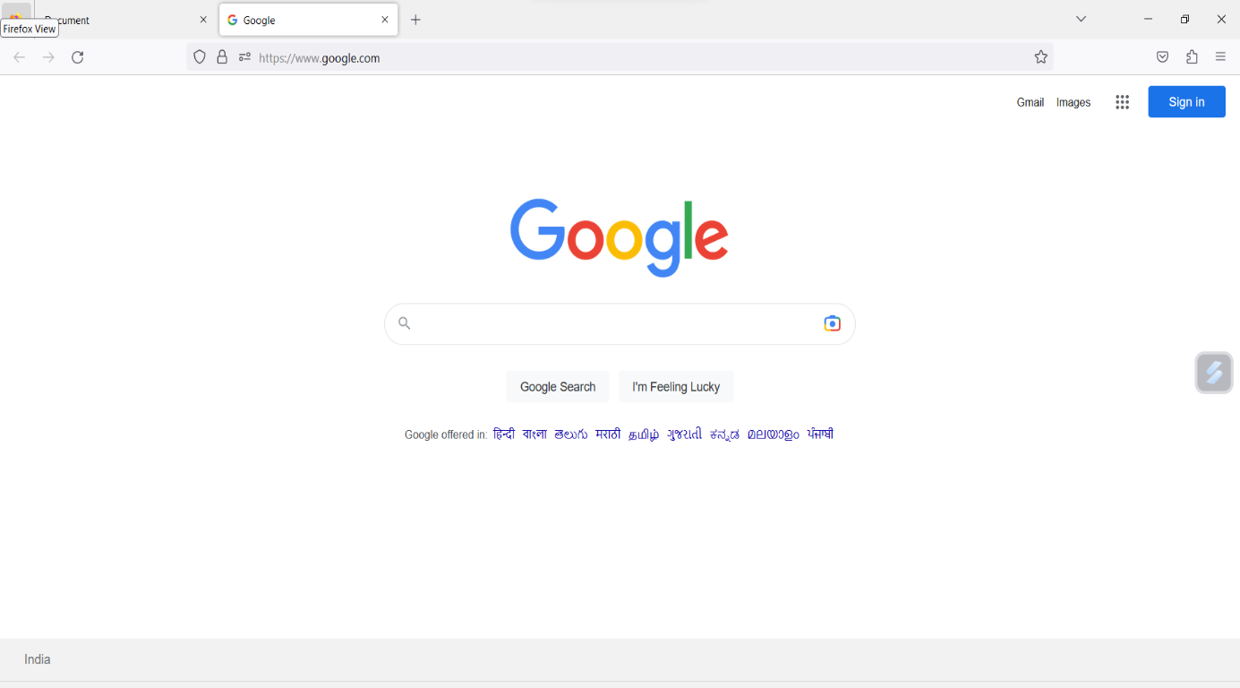

If No:

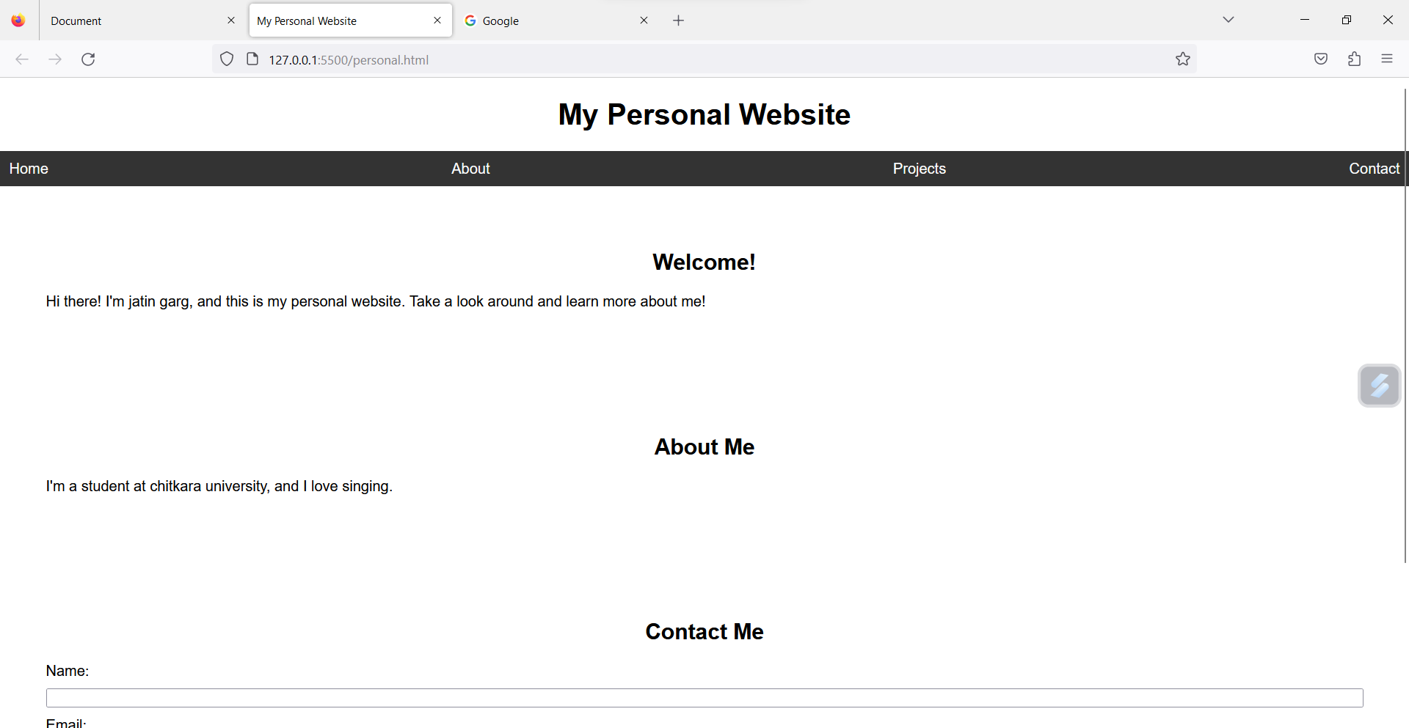

CONCLUSION:

This project helped us to learn the correct use of Html, CSS and javascript. we learned many things such as inserting an exit plug, images and buttons on are website through the project. We would like to thank our Mentor to give us this project.